Following is a short list of some of the free items i’ve collected from contacts I have in the Ed Tech industry that I have donated to schools I work with.
Date | Item | From | Relative Market Value | Image
Winter 2015 | 5 , 77” Smartboards w/speakers and 4 Unifi65 projectors | The Chruchill School | @$5,000 | 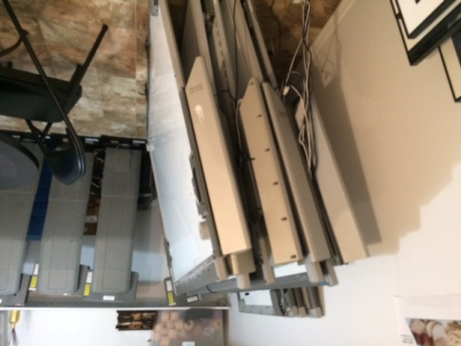
Winter 2015 | 2 TEQ- Z782DWN Projectors | The Churchill School | $1,500 - $2,500 | 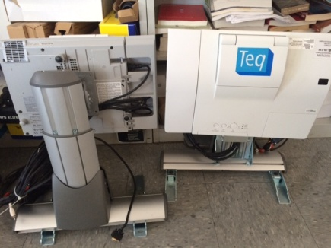
Fall 2014 | 9 piece Lighting rig for auditorium lighting | The Churchill School | $3,000 - $5,000 | 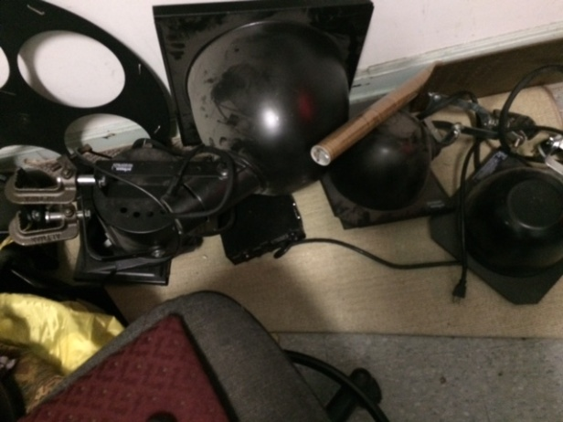
Fall 2014 | 36 Blue Socket Access Points with controller | The Churchill School | $5,000 - $10,000 | 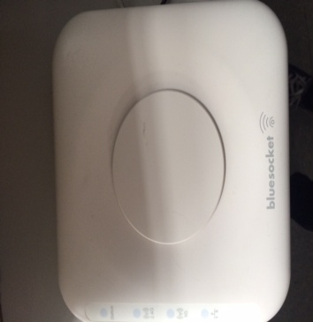
Summer 2014 | 21 iMac Desktops with Intel Duo Core Processors, 8GB RAM, 500GB Hard Drive | The Churchill School | $21,000 | 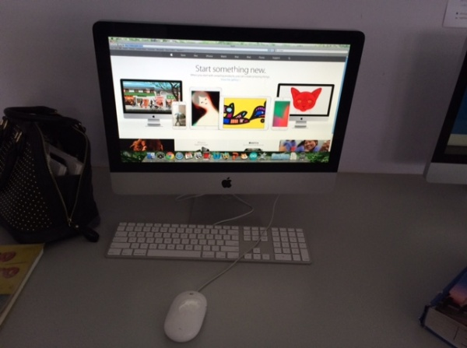
Summer 2014 | Mitsubishi XD250U Projector | Bishop Ford High School | $250
Summer 2014 | 3 Epson PowerLight Projectors | The Churchill School | $700
Summer 2014 | 2 Dell LaserJet 1815 Dn Fax/Copy/Printers, 2 Dell 2335DN Fax/Copy/Printers | US Social Security Administration | $950 | 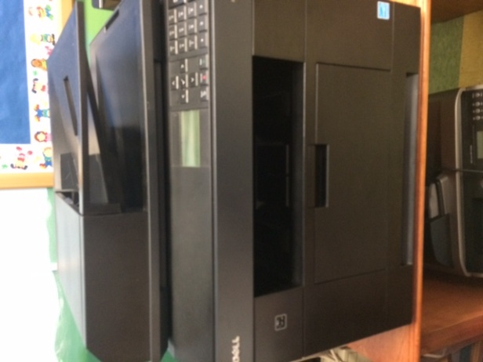
Summer 2013 | 2 HP LaserJet 500 Color M551 Printers | UNIS School | $1,100 | 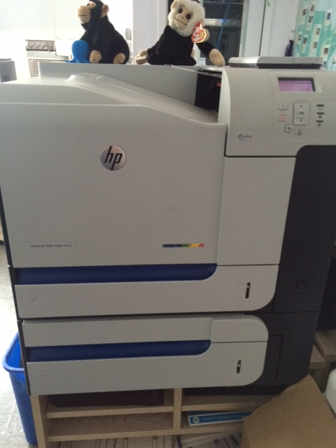
Summer 2013 | 20 SonicWall Access Points | Saddle River New Jersey Day School | $2,000 | 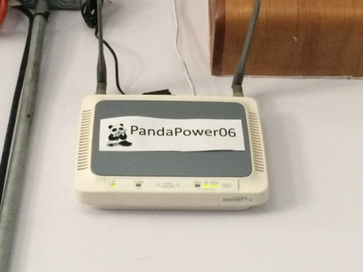
Summer 2013 | 8, 77” Smartboard 680 | Calhoun School | $8,000
Spring 2013 | 1 Dell PowerEdge R610, 1 Dell PowerEdge 2950 servers, Dell RackMount UPS, Dell KMM tray | US Social Security Administration | $4,000 | 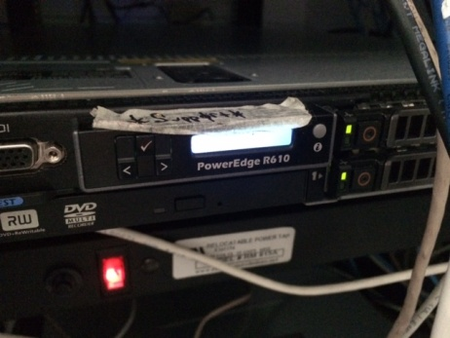
Fall 2013 | Audio Rack, Ampeg Power Amp, XLR snake | Rivington Music Studios | $1,000 | 